H.T No
Regulations:
A22

Sreenidhi Institute of Science and Technology
(An Autonomous Institution)
Code No: 9BC01 Date: 27-Mar-2023 (FN)

B.Tech I-Year I- Semester External Examination, March-2023 (Regular)
ENGINEERING GRAPHICS (CIVIL, EEE, ME, ECE and ECM)

Time: 3 Hours Max.Marks:60

Note: a) No additional answer sheets will be provided.
b) All sub-parts of a question must be answered at one place only, otherwise it will not be valued.
c) Missing data can be assumed suitably.
Bloom's Cognitive Levels of Learning (BCLL)

Remember | L1 | Apply | L3 | Evaluate | L5
Understand | L2 | Analyze | L4 | Create | L6

Part - A Max.Marks: 6x2=12

Answer all QUESTIONS, EACH QUESTION CARRIES 2 MARKS.

 |  | BCLL | CO(s) | Marks
1 | Define an Ellipse. | L1 | CO1 | [2M]
2 | Define Vertical and horizontal Planes. | L1 | CO2 | [2M]
3 | What is meant by Projection? | L1 | CO3 | [2M]
4 | Define a section Plane. | L1 | CO4 | [2M]
5 | Define Isometric projection. | L1 | CO5 | [2M]
6 | Draw the sign convention used to represent First angle projection. | L1 | CO6 | [2M]

Part – B Max.Marks: 6x8=48
ANSWER ALL QUESTIONS. EACH QUESTION CARRIES 8 MARKS.

 |  |  | BCLL | CO(s) | Marks
7. | a) | Construct an ellipse, with distance of the focus from the directrix as 50mm and eccentricity as 2/3. | L3 | CO1 | [8M]
 |  | OR
 | b) | Construct a parabola with the distance of the focus from the directrix as 50mm. Also, draw normal and tangent to the curve, at a point 40mm from the directrix. | L3 | CO1 | [8M]
8. | a) | Draw the projections of the following point,  i) A– 20mm above HP and 30mm in front of VP  ii) B – 20mm above HP and 30mm behind VP  iii) C– 20mm below HP and 30mm behind VP  iv) D– 20mm below HP and 30mm in front of VP | L1 | CO2 | [8M]
 |  | OR
 | b) | A line AB of 100mm length, is inclined at an angle of 30⁰ to HP and 45⁰ to VP. The point A is 15mm above HP and 20mm in front of VP. Draw the projections of the line. | L1 | CO2 | [8M]
9. | a) | Draw the projections of a regular pentagon of 25mm side, with its surface making an angle of 45⁰ with HP. One of the sides of the pentagon is parallel to HP and 15 mm away from it. | L1 | CO3 | [8M]
 |  | OR
 | b) | Draw the projections of a cylinder, base 50 mm diameter and axis 75mm long resting with its base on the HP axis parallel to VP. | L1 | CO3 | [8M]
10. | a) | A cylinder of 40 mm diameter, 60 mm height and having its axis vertical, is cut by a section plane, perpendicular to the VP, inclined at 45⁰ to the HP and intersecting the axis 32 mm above the base. Draw its front view, sectional top view and true shape of the section | L1 | CO4 | [8M]
 |  | OR
 | b) | A square prism of side of base 40 mm and axis 80 mm long, is resting on its base on HP such that, a rectangular face of it is parallel to VP. Draw the development of the prism. | L1 | CO4 | [8M]
11. | a) | Draw the isometric view of a square prism of side of base 35 mm and height 65 mm when its axis is (i) vertical and (ii) horizontal. | L1 | CO5 | [8M]
 |  | OR
 | b) | Draw the isometric view of a cylinder of base 50 mm diameter and 70 mm height when it rests with its base on HP. | L1 | CO5 | [8M]
12. | a) | Draw front view ,top view and side views of the of the isometric view shown in fig  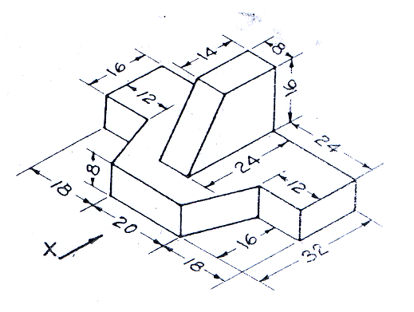 | L1 | CO6 | [8M]
 |  | OR
 | b) | Draw front view ,top view and side views of the isometric view shown in fig  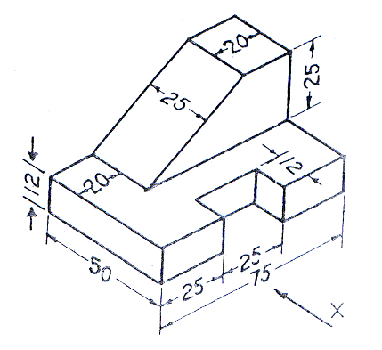 | L1 | CO6 | [8M]

-- 00 -- 00 –

